CaliforniaVolunteers is the agency within the Office of the Governor that is tasked with promoting service.

Led by Karen Baker, Chief Service Officer, CaliforniaVolunteers addresses state and community challenges by investing in high impact service solutions, while leveraging public, private, and nonprofit partnerships and resources. Through AmeriCorps, Disaster Volunteering, and Community Partnerships, CaliforniaVolunteers transforms small investments into community impact.

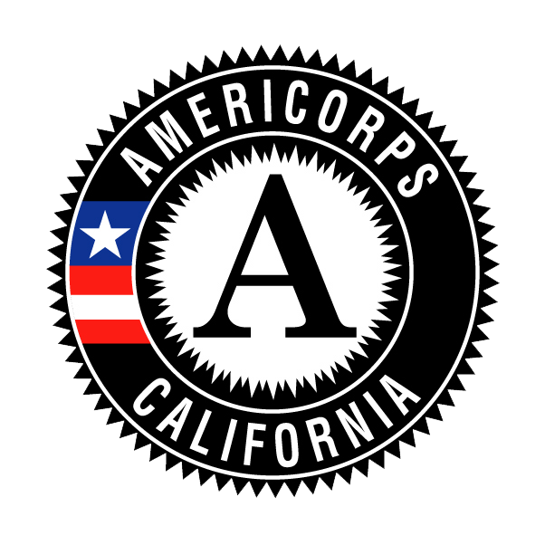
CaliforniaVolunteers is supported by a bipartisan 25-member Commission and a professional team made up of 20 staff, appointed by the Governor.

AmeriCorps: AmeriCorps is often referred to as the “domestic Peace Corps.” Participants – known as AmeriCorps members – perform a year of service with a program that meets local community needs in return for a modest living allowance and education award. For the 2016-17 program year, CaliforniaVolunteers funds 75 programs totaling more than $34.5 million that will support nearly 4,000 members serving statewide in programs that address critical community needs in education, public safety, health and human needs, and the environment.

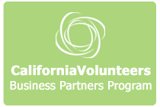
Business Partners Program: The CaliforniaVolunteers Business Partners Program facilitates partnerships between the business community, nonprofit organizations, volunteer centers, and public agencies in order to expand the number and impact of business volunteer programs across California. This program provides tools, resources, and recognition for businesses to build high-quality volunteer programs that support their communities, as well as networking opportunities. The Business Partners Program is also educated on state-priority efforts, such as the drought, in order to help the private sector better understand current community needs. Currently, there are 25 businesses participating in the program, including corporations, such as Bank of America, Deloitte, Disney, and HP.

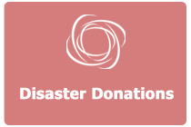
Disaster Donations: Through Executive Order S-02-08, CaliforniaVolunteers has been designated as the agency responsible for coordinating monetary donations at the state-level during disasters and has developed a Monetary Donations Strategy that outlines the state’s policy regarding monetary donations. As part of this strategy, CaliforniaVolunteers vets and signs Memorandum of Understandings with grantmaking organizations (i.e., Community Foundations and United Way Chapters) and direct service providers (such as food banks, American Red Cross, etc.) to be listed on the CaliforniaVolunteers.org website to receive public donations during a disaster.

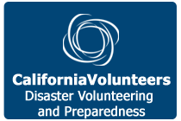
Disaster Volunteering: During a disaster, CaliforniaVolunteers’ role includes coordination of support to local government and California Governor’s Office of Emergency Services in their management of spontaneous unaffiliated and affiliated volunteer organizations. These organizations include CERT (Community Emergency Response Team), Voluntary Organizations Active During a Disaster (VOAD), national organizations such as The American Red Cross and Salvation Army, faith-based organizations, and the private sector. CaliforniaVolunteers has also developed a cadre of 1,000 government affiliated, trained volunteers as part of the Disaster Corps program.

