AmeriCorps Alums National Leadership Award/ California AmeriCorps Alums Local Leadership Award Winner
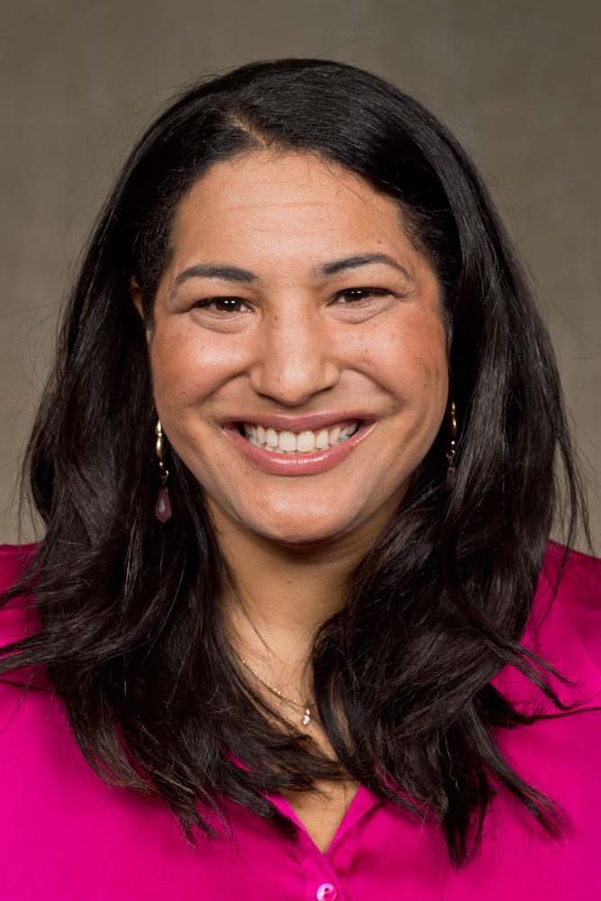
Dr. Dayna Long
Attending Physician at USCF Benioff Children's Hospital Oakland, California
Dayna (AmeriCorps VISTA volunteer service began in 1994) served as a peer health educator at the L.A. Free Clinic with Project Able. Twenty years later, Dayna is a pediatrician at UCSF Benioff Children’s Hospital Oakland working in the Primary Care Clinic and the Emergency Department. As a result of witnessing the ramifications of poverty and trauma on children, she founded and serves as the Co-Medical Director of the Family Information and Navigation Desk (FIND). FIND addresses the social and environmental factors that profoundly impact health. In addition, Dayna is her hospital’s spokeswoman for the Too Small to Fail: Talk, Read, Sing Initiative sponsored by the Bill, Hillary and Chelsea Clinton Foundation. Dayna is also Medical Director of ATTACK Asthma Clinic, which provides asthma education and management to children and families following a visit to an emergency room. During the summer, she is the Medical Director of Camp Breathe Easy, a sleep-away camp for underrepresented children who have asthma.

