AmeriCorps Alums National Leadership Award/ California AmeriCorps Alums Local Leadership Award Winner

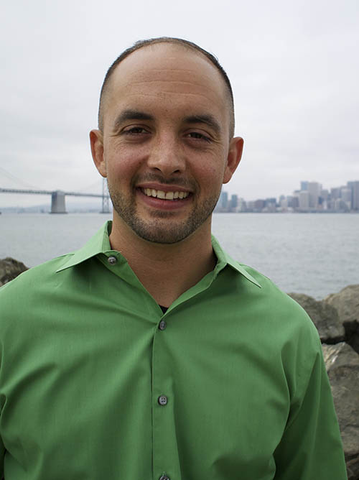
Kevin C. Miller
Strategic Partnership Associate with Swords to Plowshares
Kevin (service began in 2013 with Swords to Plowshares) is a former Sergeant in the Marine Corps infantry and multiple-tour Iraq combat veteran. During his time in service, he sustained multiple traumatic brain injuries and was diagnosed with post-traumatic stress disorder. These factors made Kevin’s transition from military to civilian life difficult. Kevin struggled in his personal life becoming unemployed with multiple DUIs. He found a new direction through an AmeriCorps VISTA volunteer position with Swords to Plowshares in California. His experience with AmeriCorps reminded Kevin to “redefine what it means to be ‘successful.’ You cannot dwell on what you cannot change, but you can use your ‘failures’ as motivation to drive towards your own definition of success.” After his service, Swords to Plowshares created a full-time position for Kevin within the Institute for Veteran Policy, and Resource Development & Communications Departments as the Strategic Partnership Associate where he ensures fellow veterans get the services and support they need to prevent chronic homelessness, poverty and untreated mental and physical health issues.

